Energy Storage Preliminary Monitoring Plan

This document is intended to assist SGIP applicants meet the requirements of the Preliminary Monitoring Plan (PMP) and allow the Program Administrators to determine project eligibility. Applicants are encouraged to use this template to satisfy the PMP requirement. Please see 2017 Handbook section 5.4.1 for more information on the PMP.
Please complete the following:
Project Site Address:
Host Customer:
System Owner:
Developer:
Storage Make: Enphase.
Model : Nos of units of Encharge-3 :
Nos of units of Encharge-10 :
Please select project type:
☒Storage (<30 kW) – Paired with and Charging at least 75% from Onsite Renewables
☐ Storage (≥30 kW) – Paired with and Charging at least 75% from Onsite Renewables
☐ Storage (≥30 kW) – Stand Alone or Charging less than 75% from Onsite Renewables

For all projects, please provide the following information:
- Describe the proposed system, including major system components.
The system comprises of the Encharge LFP battery packs, IQ family microinverters for the batteries, IQ microinverters for the PV system, Combiner box containing the inputs from PV microinverters and the smart communication device Envoy. Also the system is connected to the grid via a smart switch named Enpower which handles the import and export of power between the solar PV, Batteries and the grid, and supplies the power to a sub panel or the main panel of the home loads. For monitoring and control of the complete system, Enlighted mobile and web application is used. The system is completely grid agnostic, providing seamless transition between on-grid and off-grid mode to supply uninterrupted power.

- Describe the intended system operation and primary use case at the project site. (In other words, what specific service(s) will the storage system provide to the customer?)
The system is capable of energy arbitrage, storing excess renewable generation, and back‐up operation. The intended or primary operation mode for this site will be to employ the shifting of excess renewable generation by enabling the system to charge when excess generation is available, and to discharge to serve site loads when renewable generation is insufficient or unavailable. During utility power outages, the system is capable of providing backup power.

- Is there a “back-up only” setting or operational mode available for the storage system, whereby the system will only discharge in the event of a grid outage?
☒ Yes
☐ No

If yes, please explain how you are ensuring that this project will meet SGIP operational requirements, notwithstanding the “back-up only” option, over the 10 year permanency period:
The system has been programed to operate in a non‐backup mode as its default
operation at the time of installation. The customer has also received documentation
which states that exclusive operation of the back‐up only mode is prohibited over the 10
year permanency period, per the SGIP handbook requirements.

- Describe the existing load to be displaced by storage system operation.
The system’s regular operation will supplement whole home energy loads, which include
HVAC, lighting, and other miscellaneous plug loads and appliances, as well as serve a
load subpanel consisting of lighting and refrigeration loads and other appliances, in the
event of a grid outage.

- Insert a simplified system layout of identifying major components and the proposed metering points at the project site.
Select one of the following diagrams and modify based on site layout and metering points:
A: Subpanel backup configuration
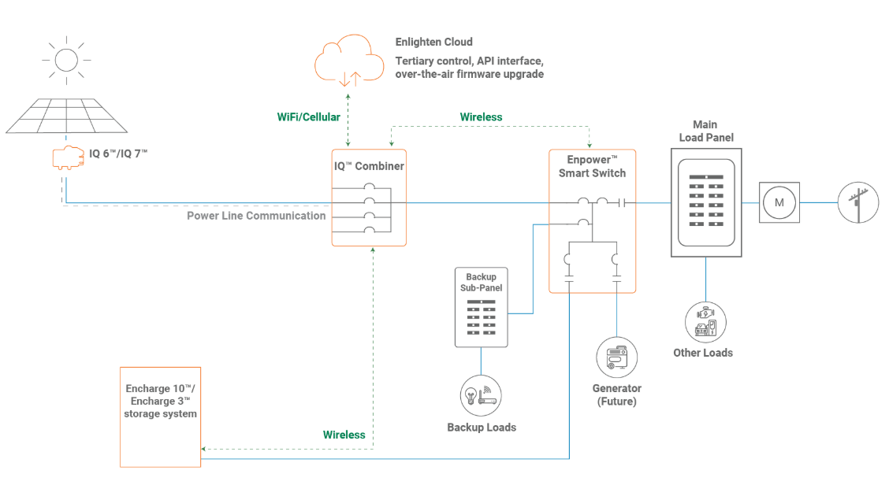
B: Main Panel backup configuration
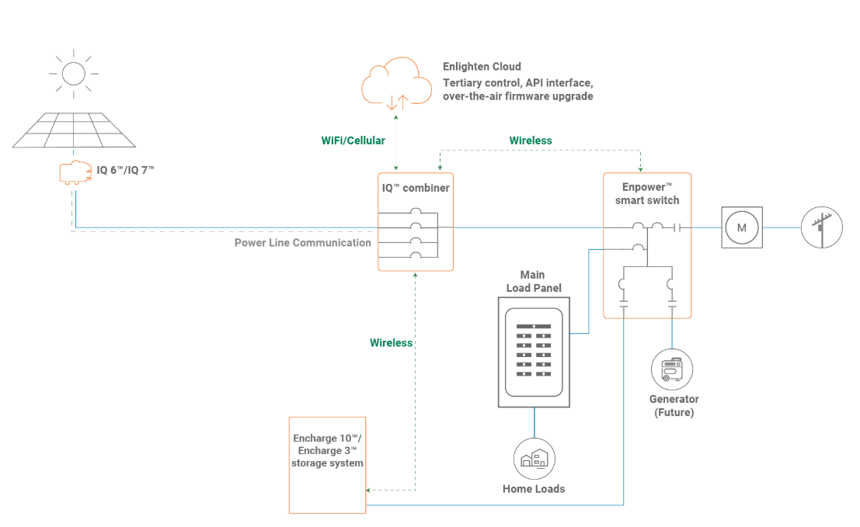

- Describe the metering components of the system, data to be collected at metering points, reasoning behind selected metering locations, and a description of the data acquisition system.
The system’s inverters/converters contain channels by which to collect individual
performance data of the PV and battery arrays. There is also a Current Transformer (CT)
to collect whole site net energy (kWh) and power (kW) consumption, called consumption CT. The internal inverter/converter channels will collect AC instantaneous power (kW) and
cumulative energy (kWh) of the PV array and battery array associated with it. There is a production CT that measures the PV generation inside the AC PV combiner box. The internal channel on the converter of the battery measure the battery charge/discharge data, and in conjunction with the data from the channel on the PV inverters, production CT, and consumption CT, will be used to calculate the percentage of renewable energy charging the battery array. The consumption CT will also be used to confirm combined system performance and energy/cost savings at the site. The data acquisition system (DAS) also uses these metering points to measure and control operation through a communications gateway.

- Describe the approach for collecting, storing and transferring operational data to the program. Describe the monitoring data source, frequency for collecting data, and the system’s data storage capabilities.
The described data to be collected, will be time stamped and logged every 15 minutes.
The internal storage space of the system can store up to two months of data locally.
Multiple times during every day, the local data is transferred to an offsite “cloud” based server, which can store up to 25 years of operation data.”

- List the make and model of the external meters or energy management system to be installed that will log and transmit operational data.
The system will use the internal capabilities of the solar PV inverter to meter the output
of the PV system, as well as an integrate production CT in the Enphase AC combiner box (X-IQ-AM1-240-3) to measure and record PV power output/input. The consumption CT is “Enphase Consumption CT - CT-200-SPLIT for IQ Envoy”

For projects paired with and charging ≥75% from onsite renewables, please provide the following information:
- How will the system charge at least 75% from onsite renewables? Describe the anticipated charge/discharge schedule and/or control approach of the storage system and operational mode(s) to be deployed for this project site.
“The system uses a proprietary control algorithm which uses the metering points to
identify periods of excess renewable generation, and signals the system to charge to
maintain zero or minimal excess generation until fully charged. Only when necessary to
maintain a minimum level of charge for battery health will the system charge from the
grid if excess solar is unavailable. The system is set to discharge when net load is above a
specified demand (kW) limit, and will discharge up to the net load above this limit or its
maximum output until the lower limit state of charge is reached. This algorithm will be
enabled everyday, year‐round.

- Who will operate the system? I.e.: Developer, Manufacturer, Host Customer, System Owner (if different from Host Customer)
System Owner
For projects ≥30 kW only, please provide the following information:

- Are the meters listed on the Go Solar California database?
☐ Yes
☐ No

- Performance Data Provider (PDP)
PDP is not required as the system has below 30kW of output power.
- How will the storage system’s operational data be transferred to the PDP for monthly reporting?

